CSA0994 – PROGRAMMING IN JAVA FOR DUMMIES

Day -1 Programs

Program 1: Even Odd Numbers

Code:

import java.util.*;  
public class EvenOdd {  
 public static void main(String[] args) {  
 Scanner sc=new Scanner(System.*in*);  
 System.*out*.println("enter a number");  
 int n=sc.nextInt();  
 if(n%2==0) {  
 System.*out*.println(n+" is even number");  
 }  
 else {  
 System.*out*.println(n+" is odd number");  
 }  
 }  
}

Output:

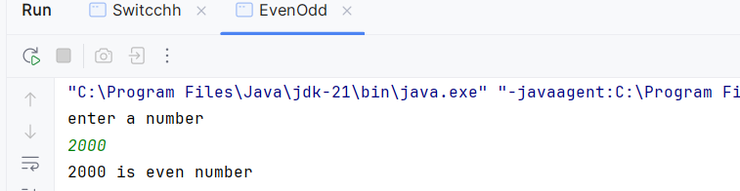

Program 2: Greatest Number in Array

Code:

import java.util.*;  
public class GreatestArray {  
 public static void main(String[] args) {  
 Scanner sc = new Scanner(System.*in*);  
 System.*out*.print("Enter size of the array: ");  
 int n = sc.nextInt();  
 int arr[] = new int[n];  
 System.*out*.println("Enter the elements of the array:");  
 for (int i = 0; i < n; i++) {  
 arr[i] = sc.nextInt();  
 }  
 int max = arr[0];  
 for (int i = 1; i < n; i++) {  
 if (arr[i] > max) {  
 max = arr[i];  
 }  
 }  
 System.*out*.println("The greatest element in the array is: " + max);  
 }  
}

Output:

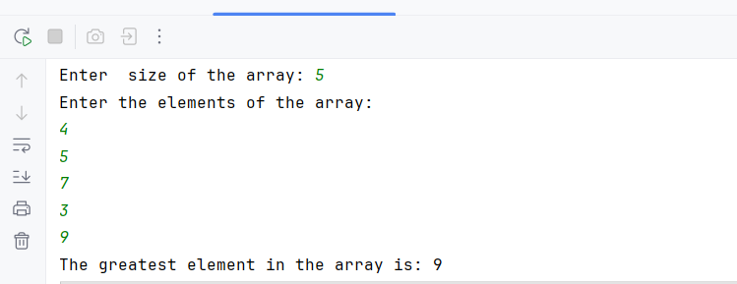

Program 3: Second Greatest element in array

Code:

public class SecondMax {  
 public static void main(String [] args)  
 {  
 int max=Integer.*MIN_VALUE*;  
 int smax=Integer.*MIN_VALUE*;  
 int[] arr={1,2,3,4,5};  
 for(int i=0;i<arr.length;i++)  
 {  
 if(arr[i]>max)  
 {  
 smax=max;  
 max=arr[i];  
  
 }  
 }  
  
 System.*out*.println("Second maximum element:"+smax);  
 }  
}

Output:

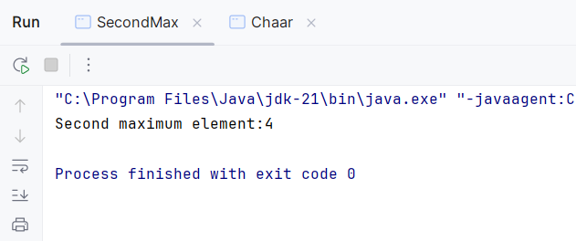

Program 4: Array Multiplication:

Code:

public class Array  
{  
 public static void main(String args[]){  
 *// int a[]=new int [5];  
 //a[0]=2;  
 //System.out.println(a[1]);* int c[]={5,4,3,2,1};  
  
 int a[][]={{1,2,3},{4,5,6},{7,8,9}};  
 int b[][]={{1,2,3},{4,5,6},{7,8,9}};  
 int i,j;  
 for (i=0;i<a.length;i++)  
 {  
 for (j = 0; j < a.length; j++)  
 {  
 System.*out*.println(a[i][j]*b[i][j]);  
 }  
  
 }  
  
 }  
}

Output:

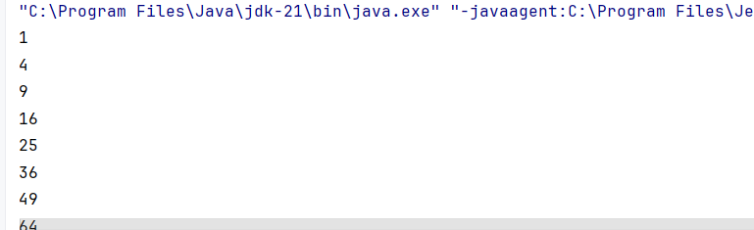

Program 5: Boolean Expressions

Code:

public class Boolean  
{  
 public static void main(String args[])  
 {  
 boolean b1=false||false;  
 boolean b2=false||true;  
 boolean b3=true||false;  
 boolean b4=true||true;  
 System.*out*.println(b1);  
 System.*out*.println(b2);  
 System.*out*.println(b3);  
 System.*out*.println(b4);  
  
 }  
}

Output

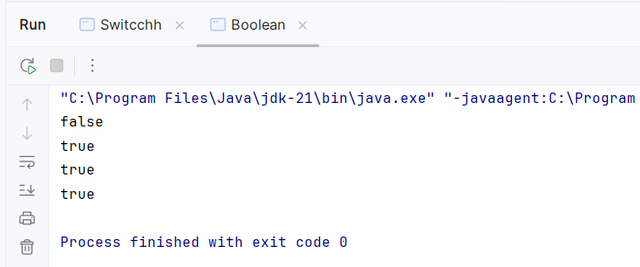

Program 6: Charater Input

Code:

import java.util.Scanner;  
  
public class Chaar  
{  
 public static void main(String args[])  
 {  
 Scanner sc=new Scanner(System.*in*);  
 char[] s="Hello".toCharArray();  
 String gg="Helloiamgood";  
 System.*out*.println(gg.charAt(6));  
 char[] a="Hello".toCharArray();  
 System.*out*.println(a);  
  
 }  
}

Output:

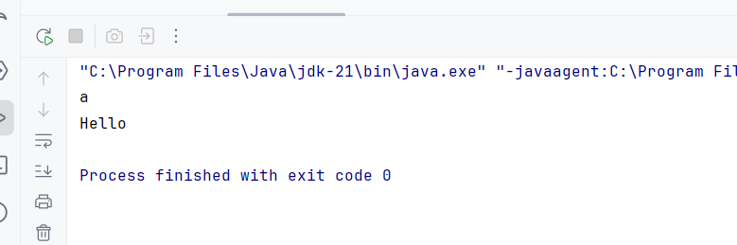

Program 7: Switch case using

Code:

import java.util.Scanner;  
  
public class Switcchh {  
 public static void main(String args[]) {  
 Scanner sc = new Scanner(System.*in*);  
 System.*out*.println("Select a number from 1 to 4:");  
 char sel = sc.next().charAt(0);  
 System.*out*.println("Number selected is " + sel);  
  
 switch (sel) {  
 case '1':  
 System.*out*.println("A selected");  
 break;  
 case '2':  
 System.*out*.println("B selected");  
 break;  
 case '3':  
 System.*out*.println("C selected");  
 break;  
 case '4':  
 System.*out*.println("D selected");  
 break;  
 default:  
 System.*out*.println("Invalid selection");  
 }  
 }  
}

Output:

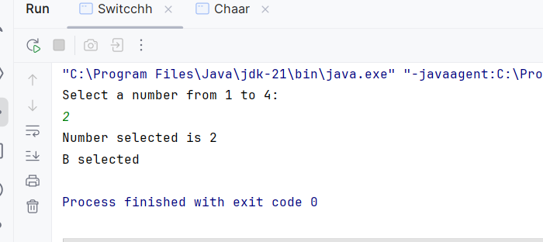

Program 8: Array Sorting Using Predefined

Code:

import java.util.Arrays;  
public class SortingArray  
{  
 public static void main(String args[])  
 {  
 int a []={2,4,6,1,9};  
 int b []={5,3,4,8,7};  
 Arrays.*sort*(a);  
 Arrays.*sort*(b);  
 System.*out*.println(Arrays.*toString*(a));  
 System.*out*.println(Arrays.*toString*(b));  
 }  
}

Output:

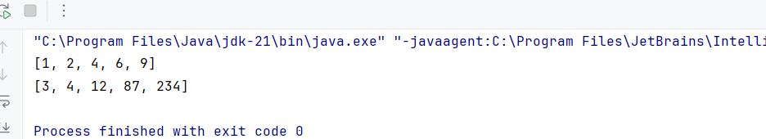

Program 9: Interface

Code:

interface Interfaceee  
{  
 abstract int add(int a, int b);  
  
 abstract int sub(int a, int b);  
  
 abstract int mul(int a, int b);  
  
 abstract int div(int a, int b);  
}  
class Inter_Child implements Interfaceee {  
 public int add(int a, int b) {  
 int c;  
 c = a + b;  
 System.*out*.println(c);  
 return c;  
 }  
  
 public int sub(int a, int b) {  
 int c;  
 c = a - b;  
 System.*out*.println(c);  
 return c;  
 }  
  
 public int mul(int a, int b) {  
 int c;  
 c = a * b;  
 System.*out*.println(c);  
 return c;  
 }  
  
 public int div(int a, int b) {  
 int c;  
 c = a / b;  
 System.*out*.println(c);  
 return c;  
 }  
  
 public static void main(String args[])  
 {  
 Inter_Child ic=new Inter_Child();  
 ic.add(5,9);  
 ic.sub(4,2);  
 ic.mul(3,6);  
 ic.div(16,4);  
 }  
}

Output:

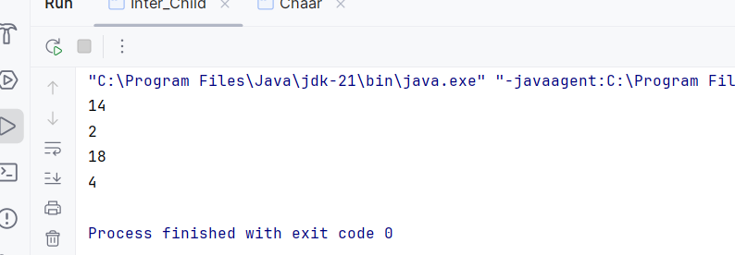

Program 10 : Exception handling

1. Arithematic Exception:

Code:

public class Except  
{  
 public static void main(String args[])  
 {  
 try  
 {  
 int a,b,c;  
 a=7;  
 b=0;  
 c=a/b;  
 System.*out*.println(c);  
  
 }  
 catch(Exception e)  
 {  
 System.*out*.println(e);  
 }  
 finally {  
 System.*out*.print("All The Best");  
 }  
 }  
}

Output:

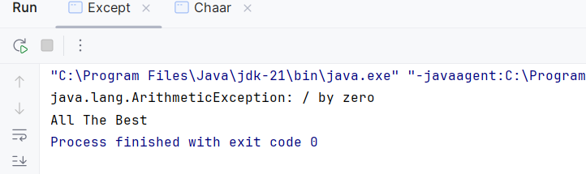

1. Array Index Exception:

Code:

public class Except  
{  
 public static void main(String args[])  
 {  
 try  
 {  
 int g[] ={1,2,3,4,5,6};  
 System.*out*.println(g[6]);  
  
 }  
 catch(Exception e)  
 {  
 System.*out*.println(e);  
 }  
 finally {  
 System.*out*.print("All The Best");  
 }  
 }  
}

Output:

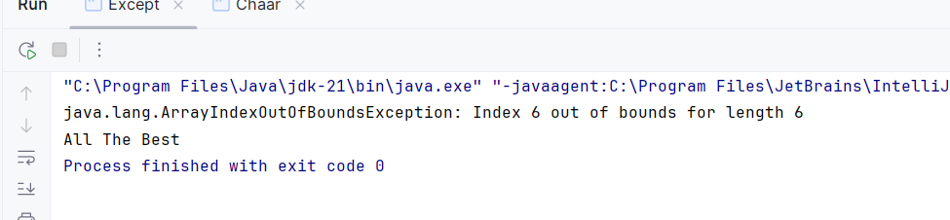

Program 11: List

Code:

import java.util.*;  
  
public class Lisstt  
{  
 public static void main(String args[])  
 {  
 List l=new ArrayList();  
 Set s=new TreeSet();  
 s.addAll(l);  
 Date d=new Date();  
 System.*out*.println(d);  
 l.add(1);  
 l.add(2);  
 l.add(3);  
 l.add(4);  
 System.*out*.println(l);  
 l.add("Pavani");  
 l.add("Hemanth");  
 l.add("Sravani");  
 l.add("Sasank");  
 System.*out*.println(l);  
 Collections.*shuffle*(l);  
 *// Collections.replaceAll(1,"Sasank","Sushanth");  
 // Collections.sort(l);  
 //Collections.rotate(1,2);* }  
}

Output:

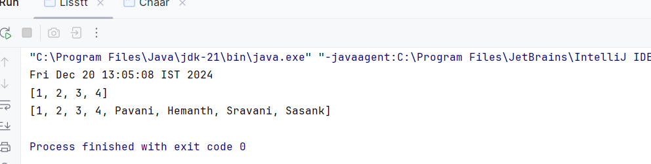

Program 12: Abstract Class

Code:

abstract class AbstractSample {  
 String uname(String fname, String lname)  
 {  
 fname="Pavani";  
 lname="Kankanampati";  
 return fname+" "+lname;  
 }  
 String contact(String email, String phone,String address)  
 {  
 email="Pavani@gmail.com";  
 phone="9999999999";  
 address="Palnadu, AP";  
 return email+" "+phone+" "+address;  
 }  
 abstract double id(int regno, double score);  
}  
public class Abstraction extends AbstractSample  
{  
 double id(int regno, double score)  
 {  
 regno=12;  
 score=9.2;  
 return score;  
 }  
 public static void main(String ar[]) {  
 Abstraction a = new Abstraction();  
 System.*out*.println(a.contact("Hemanth@gmail.com", "8888888888", "Kakinada, AP"));  
 System.*out*.println(a.uname("George", "Daniel"));  
 System.*out*.println(a.id(13, 8.4));  
 }  
}

Output:

